|  |
| --- |
| SFU |
| STAT 485 Assignment 1 |
| Kun Yang 301178299 |

|  |
| --- |
|  |

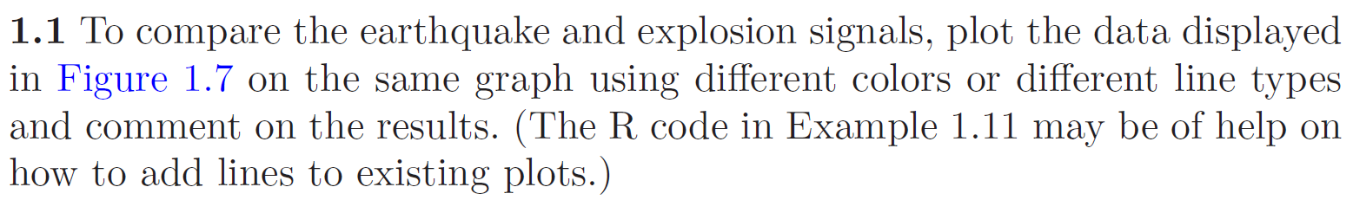

> plot(EQ5,col="blue",main="Earthquake & Explosion"，ylab="EQ5 & EXP6")

> lines(EXP6,col="red",lty=3)

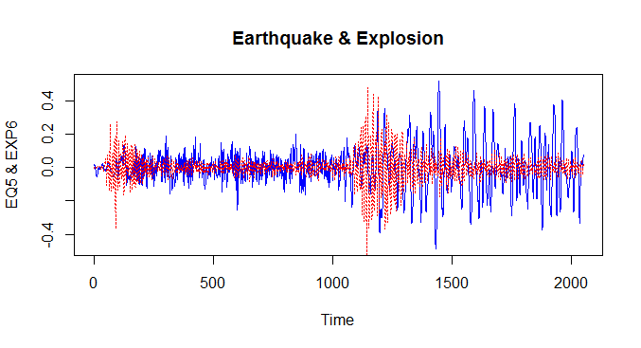

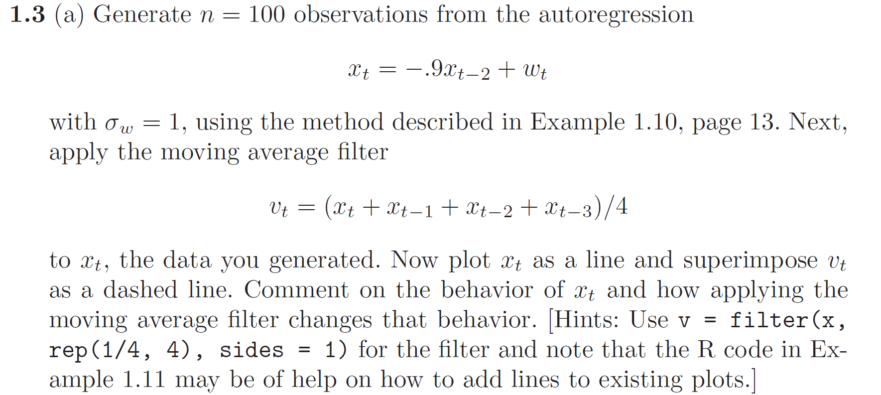

> setwd("C:\\Users\\Kun\\Desktop\\485")

> heads=scan("coindata.txt")

> w=(heads-5)/sqrt(2.5)

> x=filter(w,filter=c(0,-0.9),method="recursive")

> v=filter(w,rep(1/4,4),sides=1,method="convolution")

> plot.ts(x,ylab="x,v",main="x & v of Coin data")

> lines(v,col="red",lty="dashed")

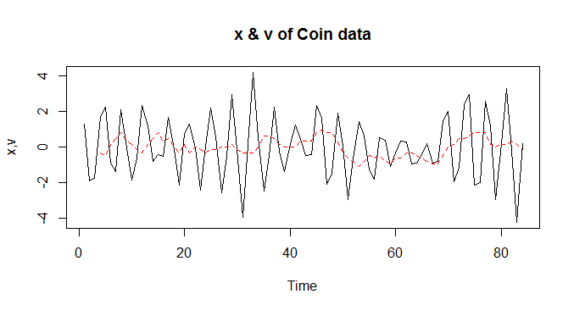

> W=rnorm(150,0,1)### 50 extra to avoid startup problems

> x=filter(W,filter=c(0,-0.9),method="recursive")[-(1:50)]

> v=filter(x,rep(1/4,4),sides=1,method="convolution")

> plot.ts(x,ylab="AR & MA",main="Autoregression & Moving Average")

> lines(v,col="red",lty="dashed")

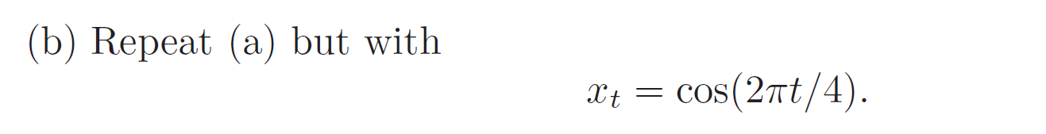

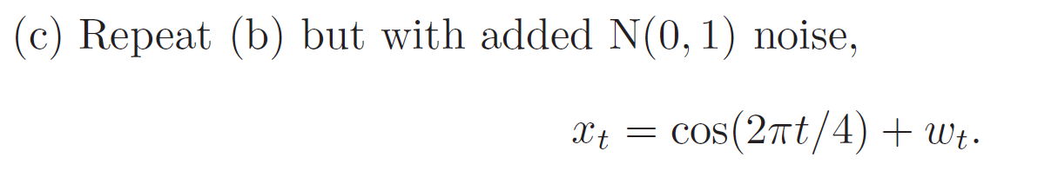

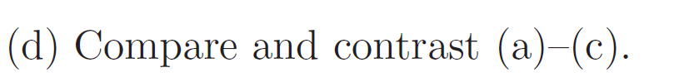

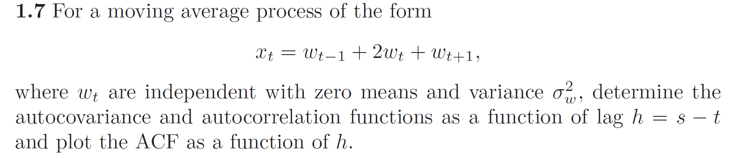

> acf=ARMAacf(ma=c(2,1), lag.max=10)

> acf

0 1 2 3 4 5 6 7

1.0000000 0.6666667 0.1666667 0.0000000 0.0000000 0.0000000 0.0000000 0.0000000

8 9 10

0.0000000 0.0000000 0.0000000

> lags=0:10

> plot(lags,acf,xlab="Lag",ylab="ACF",type="h", main = "ACF plot")

> abline (h=0,col="red")

